Kindergarten Homework Description
February 24th- February 28th, 2020

THIS WEEK IS OUR CELEBRATION OF 100 DAYS OF SCHOOL. BECAUSE OF THE CELEBRATION THE HOMEWORK WILL LOOK DIFFERENT THIS WEEK. THE KINDERGARTEN CHILDREN WILL COMPLETE ACTIVITIES THAT FOCUS ON THE NUMBER ‘100’. THERE WILL BE NO LETTER HOMEWORK THIS WEEK.

100’s Day Water Bottle Projects are due on Tuesday February 25th. Below is a picture of some sample projects.
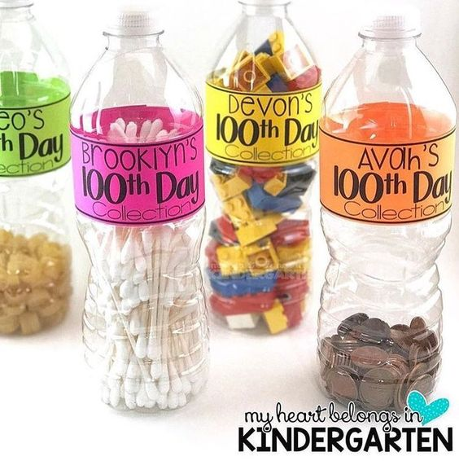

PARENT REMINDER
***ON THURSDAY FEBRUARY 27th we are asking that all kindergarten children come to school dressed like they are 100 years old. Please do not have your child dress in their school uniform. To dress like you’re 100 years old the children can have gray hair, hair curlers, glasses, shawl, robe, bow tie, gray beard/ mustache, cane or knee highs. Use your imagination!!! Thank you for helping us celebrate the 100th Day of School.***

Examples of how to dress:
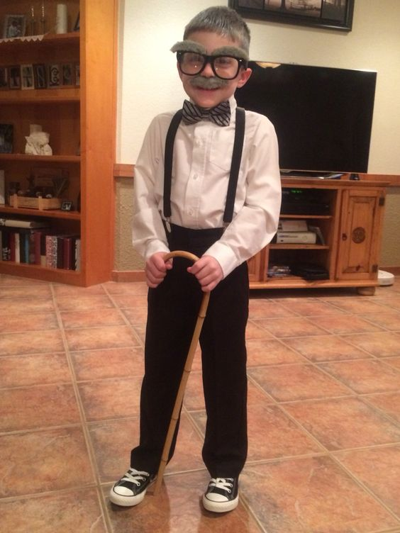

1. Monday February 24th:
a. Finish Water Bottle Project and complete the worksheet ‘100 Gumballs’

2. Tuesday February 25th:100’s DAY WATER BOTTLE PROJECTS ARE DUE TODAY!!
a. Complete the worksheet ‘Missing Numbers’.

3. Wednesday February 26th:
KINDERGARTEN CHILDREN NEED TO COME TO SCHOOL DRESSED LIKE THEY ARE 100 YEARS OLD. PLEASE DO NOT SEND YOUR CHILD TO SCHOOL WEARING HIS/HER UNIFORM.
a. Complete the worksheets ‘100 Day Workout’ and ‘100 Days I Didn’t Know’. For the ‘100 Days I Didn’t Know’ parents please write what your child didn’t know on the lines and have your child draw and color a picture in the box. The picture needs to match what has been written.

4. Thursday February 27th:
a. Complete the worksheets ‘Counting by 10’s’ and ‘100 Day Monster’.

5. Friday February 28th: MORNING KINDERGARTEN CHILDREN ATTEND SCHOOL TODAY. PLEASE MAKE SURE THAT YOUR CHILD’S BLUE HOMEWORK DUOTANG IS RETURNED TO SCHOOL.

